**Importing Zipped Eclipse Projects into Eclipse**

To import the zipped projects that are bundled with the tutorials, follow these steps:

1. Download the .zip file.
2. Open Eclipse. The projects were created in Eclipse, but the pieces can easily be copied to projects in NetBeans, MyEclipse, or IDEA.
3. Go the the File menu and select "Import".

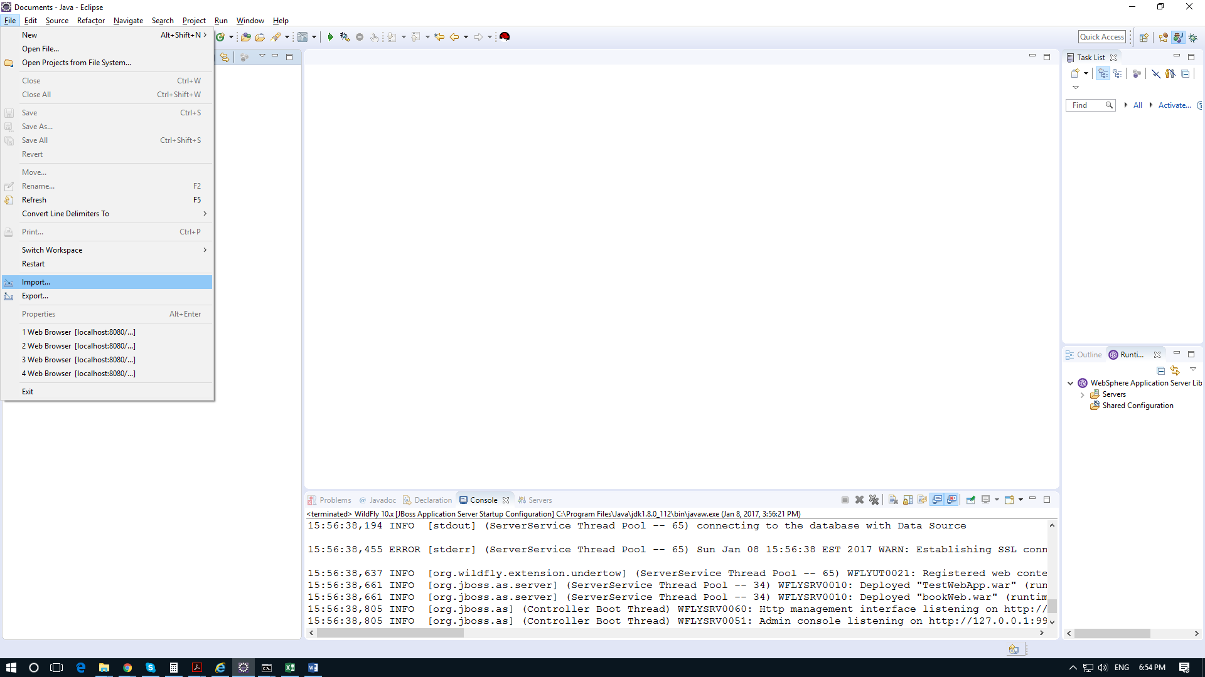

1. Choose "Existing Projects into Workspace". Do *not* choose "Archive File" directly from "Import". Press the "Next" button.

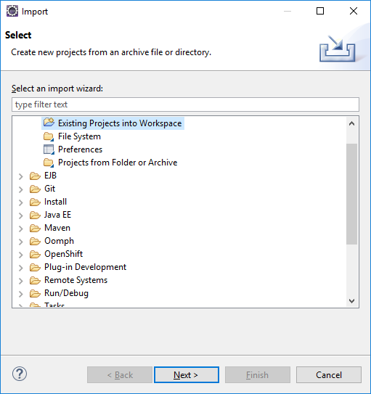

1. Choose the second radio button that says "Select archive file". Press the "Browse" button and navigate to the .zip file you downloaded in Step 1. Press "Next" and follow the directions from there.

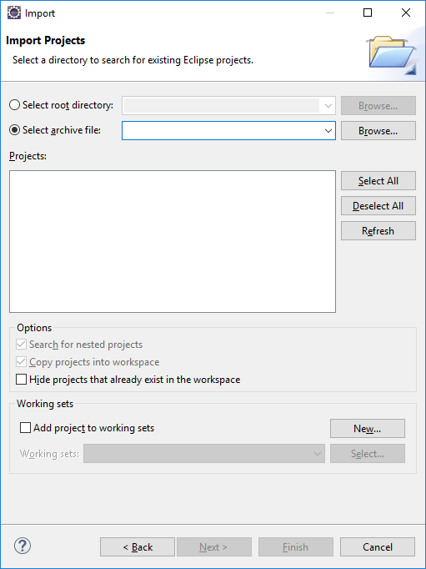

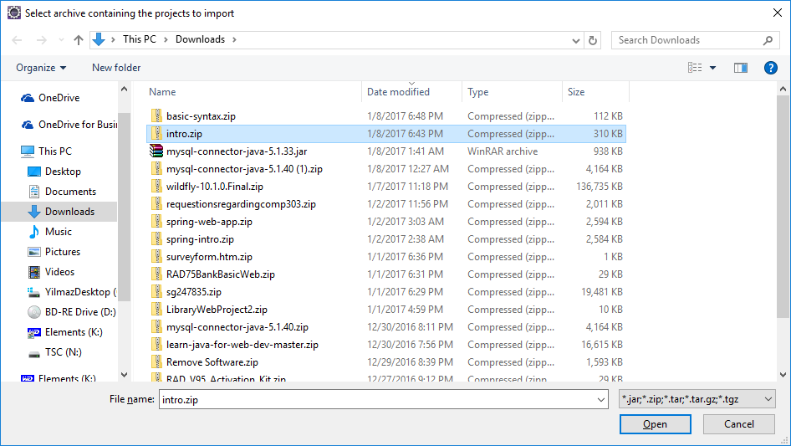

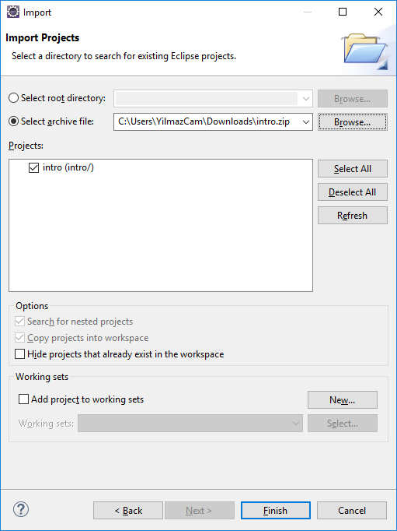

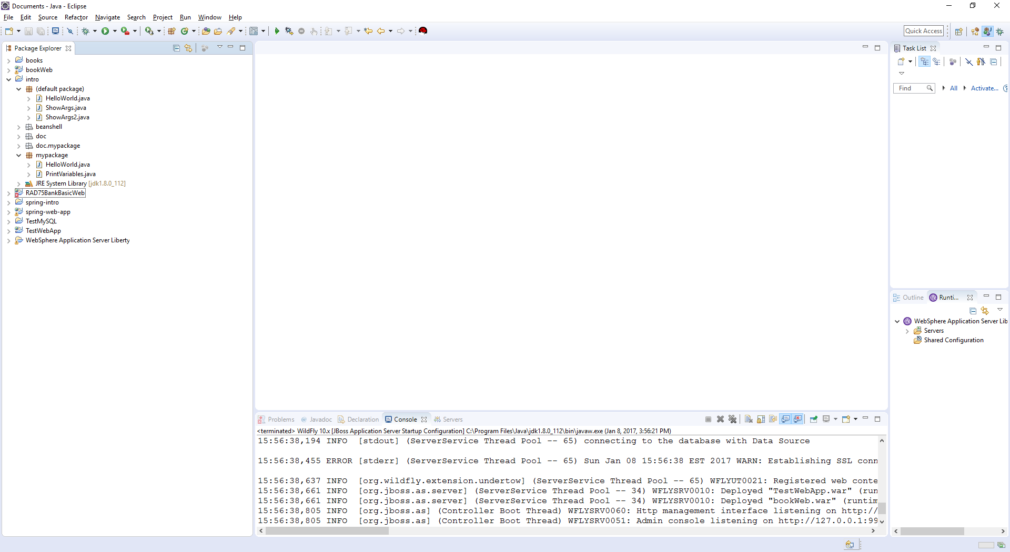

1. Most of the servlet/JSP, Ajax, JSF, Spring, Hibernate, EJB3, GWT, and Web Service projects assume that you already have WildFly or another server configured for use in Eclipse. If you don't have this set up already, see other how-to-documents explaining server configuration.